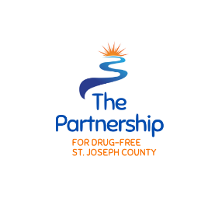
Partnership for a Drug-Free St. Joseph County
Annual Grant Letter of Intent (LOI) 2022

Name of Applicant Organization:
Address of Organization:
Name of Person completing application:
Email:
Phone:

Category applying for (Please check one):
Funding must fall into one of 3 categories for funding. Prevention which encompasses programs, activities, services or materials aimed at deterring individuals from use or abuse of substances; Treatment/Intervention encompassing services for those identified as in need of recovery from problems associated with excessive or inappropriate use of a substance; Justice services/Activities encompasses programs that assist law enforcement, courts, correctional facilities, probation services, and community corrections with individuals who have substance use disorders.
Prevention ______
Treatment/Intervention ______
Justice Services/Activities ______

Total asking amount: $ _____________
Is this a new project?
Yes ____
No ____

Please tell us about the project you are applying for: (300 words or less)

How would the mission of the Partnership for a Drug-Free SJC be furthered by this project?

How would this project fulfill objectives and outcome outlined in the Comprehensive Community Plan?

A requirement of submitting this Letter of Intent is the completion of a presentation and interview by the organization with the Partnership for a Drug-Free SJC Executive Committee.
Will you (or someone in your organization or collaborating with you on this opportunity) be able to be present to do this?
Yes ____
No ____

Please submit completed LOI to Robin Vida, Chair, at rmeleski@sjcindiana.com no later than Friday, October 21, 2022 at 8:00 p.m.

